How to come back to yourself..
By Lindsey Porter of Yoga~Nu~U

There are different statistics around how common it is for people to suffer from back pain but one thing is for sure, it effects very many of us and we are all likely at some point in our lives to have it. There’s a raft of things can trigger pain in this vital area of our body. It can be caused by a muscle, tendon or ligament strain and can go away fairly easily. It can also be pain that starts quickly but then reduces after a small amount of time or it can be chronic, where pain might last on and off over a prolonged amount of time.

As a yoga practitioner and teacher for over ten years I have an increasingly good awareness and respect for maintaining a supple and flexible back. I wasn’t prepared however for the effects that two caesarean section births in my late 30s would have on my back. It has not been or felt the same since but I have discovered that the pain is not static and with determination, a bit of patience and a lot of examining my ego and expectations it can improve.

They say the secret to a long life is maintaining a flexible spine. So how exactly can we embrace this alongside the trials and tribulation of everyday living?
Well, there are a lot of good resources out there on what you can do to help
identify, prevent, alleviate and recover from back pain and its worth investing
some time to understand this so that you can decide what is best for you.
A good starting website link is: http://www.nhs.uk/Conditions/Backpain/Pages/Introduction.aspx

My insights include starting off with mindfully doing some specific yoga postures to help strengthen the back, seek to keep a consistent practice whilst listening to your body too. I’ve also found an Aloe based heat lotion very effective at relieving more acute or reoccurring areas of aches or back pain.
So what exactly can yoga do to help? Yoga translates to ‘union’; a way of being that connects our movement (postures or asana’s) with our breath (pranayama) and our mind. From ancient scriptures certain movements have been specified which help open up and improve flexibility, strengthening the back.

Yoga poses recommended to help you come back to yourself include: Cat/Cow posture, Sphinx working up to Cobra as the back dictates and Bridge pose which can then move into deeper poses like the Wheel. More details below on how to work your way through these.
Take your pose mindfully, be in the moment and be aware. Let your breath be your guide which by that I mean that if you find it becoming ragged or quickened it can be a sign that the effort is to strong for you and you need to come back and modify or take a short rest. Remember also that each day your practice will be different so by tuning into your inner guide you can more easily judge how deep your body needs to go in any particular practice.

Cat/Cow pose: Start on your hands and knees. Position your hands directly beneath your shoulders and your knees directly beneath the hips. Have your fingers fully spread. Start with your back in a neural position, horizontal and flat. When your pelvis is in neutral, your spine will be at full extension, with both the front and back sides equally long. As you inhale tilt the pelvis up and raise your chin and chest upwards. As you exhale come back through neutral and then tuck the chin to chest lowering the crown of the head to points down, draw your navel towards your back and round your buttocks downwards and feel your back gently arch upwards. Repeat for as many times as you feel comfortable.

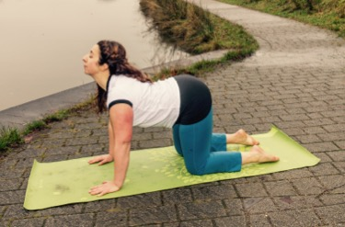  Cat | Cow

Sphinx/Cobra pose: Start by lying on your front, raise your head up looking forward and come onto your forearms into Sphinx pose. For Cobra a deeper back posture place your hands palms down on either side, with the tips of fingers about level with your shoulders. Let the head look forwards with the chin slightly tilted upwards. Start to lift your body up drawing down into your hands, keeping the buttock muscles relaxed and the top of your feet resting on the ground or mat behind you. Keep moving the shoulders you’re your back allowing space between your shoulders and your ears. Raise your body only up to where it feels right for you. If this is too much you can lower gently down, there should no pinching sensations in the back with these postures.

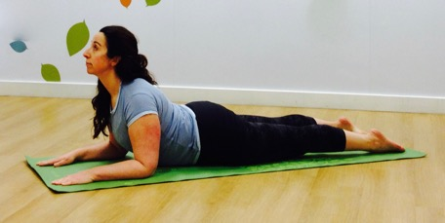  Sphinx | 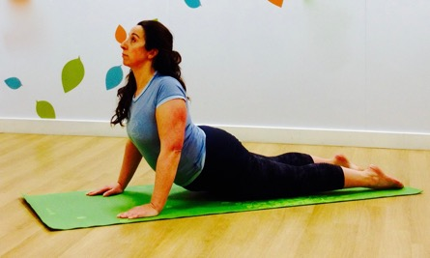  Cobra

Bridge Pose: Start by Lying on your back with your knees bent, feet together. Keep your arms by your side, palms facing downwards. Lift your hips upwards off the ground keeping your feet and palms grounded into the earth. You can adjust your arms to clasp your fingers together underneath your back whilst encouraging the hips to continue to lift upwards, allowing your gaze to be along the front of your body. Ideally keep raised for a few breaths, then to lower come up onto your tiptoes and gently lower allowing the back to curl back down to the ground. When you body strengthens you may decide to move into full wheel pose, placing your hands either side of your ears and lifting up into wheel. Always come down from these poses very gently ideally lowering your veterbrae one at a time.

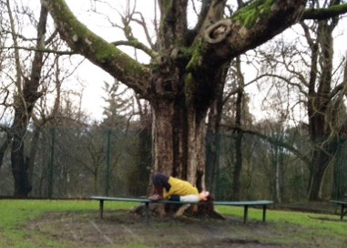 | 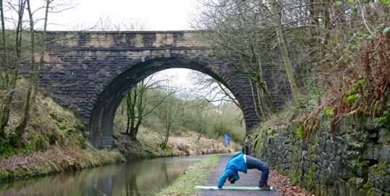
Bridge | Wheel

After doing any yoga asana’s or poses it is always beneficial to allow yourself time to let your body relax and absorb the benefits of your practice as well as your mind to settle.

There are many DVDs, online videos you can look up to follow and do yourself at home or find a local yoga class. Be sure to let your teacher know of any back issues or pain you have so they can help you modify and support your practice. And if you’d like to join me for a yoga class find out class details or how to get in touch at: www.yoganuu.weebly.com

“Life is full of setbacks. Success is determined by how you handle setbacks.”

